# Diptej Saner

USC ID 2133531420

# Multimedia Systems Assignment 2

Q.1

* The dominant wavelength of color D can be found by drawing a line from the point E to D and extending it to the edge of the diagram.
* Not all colors have dominant wavelength. For example, consider the color purple which is a mixture of red and bluish violet does not have a dominant wavelength as it is not a pure color.
* The complementary color of C can be shown by drawing a straight line from C passing through the point E to the edge of the color space, which when mixed together with that color produces white color.

Q.2

* The quantized sequence is 22 24 24 28 28 28 25 26 26 26 21 19 20 20 22 24 24 24 23 24 20 16 10 10 8 11 6 9 9 12 15 19
* We will need 5 bits to transmit the above sequence
* The difference values are 2 0 4 0 0 -3 1 0 0 -5 -2 -1 0 2 2 0 0 -1 1 -4 -4 -6 0 -2 3 -5 3 0 3 3 4

The Max difference is 4 and the minimum difference is -6. So, the range is 10, 4 bits will be required to encode the sequence.

Total bits = 31 * 4 = 124 bits

* Compression ratio = 1:0.8
* Huffman codes:

Value Frequency Code

-6 1 00000

-3 1 00001

-2 2 0001

-5 2 0010

-4 2 0011

-1 2 1000

1 2 1001

4 2 110

2 3 111

3 4 101

0 10 01

Total bits to encode the sequence = 5 + 5 + 4*2 + 4*2 + 4*2 + 4*2 + 4*2 + 3*2 + 3*3 + 2*10 = 96 bits

* Compression achieved = 124/96 = 1.3

Q.3

* There are 2x2x2 = 8 types of 3 symbol units.

Their probabilities are as follows:

AAA = 0.8x0.8x0.8 = 0.512

AAB = 0.8x0.8x0.2 = 0.128

ABB = 0.8x0.2x0.2 = 0.032

ABA = 0.8x0.2x0.8 = 0.128

BBB = 0.2x0.2x0.2 = 0.008

BBA = 0.2x0.2x0.8 = 0.032

BAA = 0.2x0.8x0.8 = 0.128

BAB = 0.2x0.8x0.2 = 0.032

* First divide the interval [0 1] in 2 parts [0 4/5] for A and [4/5 1) for B

The interval [0 4/5] is divided into [0 16/25] for AA and [16/25 4/5] for AB

Similarly,

[0 16/25] is divided into [0 64/125] for AAA (1) and [64/125 80/125] for AAB (101)

[16/25 4/5] is divided into [80/125 96/125] for ABA (11) and [96/125 100/125] for ABB (11001)

Now considering the other interval, it is divided into [4/5 24/25] for BA and [24/25 1) for BB

Similarly,

[4/5 24/25] is divided into [100/125 116/125] for BAA (111) and [116/125 120/125] BAB (1111)

[24/25 1] is divided into [120/125 124/125] for BBA (11111) and [124/125 1) BBB (11111)

Converting the fraction to binary we get,

0.10000011000100100111 64/125

0.10100011110101110001 80/125

0.1100010010011011101 96/125

0.11001100110011001101 100/125

0.11101101100100010111 116/125

0.11110101110000101001 120/125

0.11111101111100111011 124/125

Using the above binary values, we can calculate the least number of bits required to represent the respective intervals for 3 symbol units.

AAA 1

AAB 101

ABA 11

ABB 11001

BAA 111

BAB 1111

BBA 11111

BBB 1111111

Converting the above codes to prefixed codes we get:

AAA 100

AAB 101

ABA 11000

ABB 11001

BAA 1110

BAB 11110

BBA 111110

BBB 1111111

* Average code length = (0.512 x 3 + 0.128 x 12 + 0.032 x 16 + 0.008 x 7) = 3.64

It is not optimum as the entropy of the symbol units comes out to be 2.122 which is less than 3.64 and hence further compression can be achieved.

* The message converted to bits = 11000111110110011001111111

26 bits are required to encode the message

Q.4

* P(X) = x^2 and P(Y) = (1-x^2)

Entropy H = - ∑(Pk log Pk)

H = -[x2 log x2 + (1 – x2) log (1 – x2)]

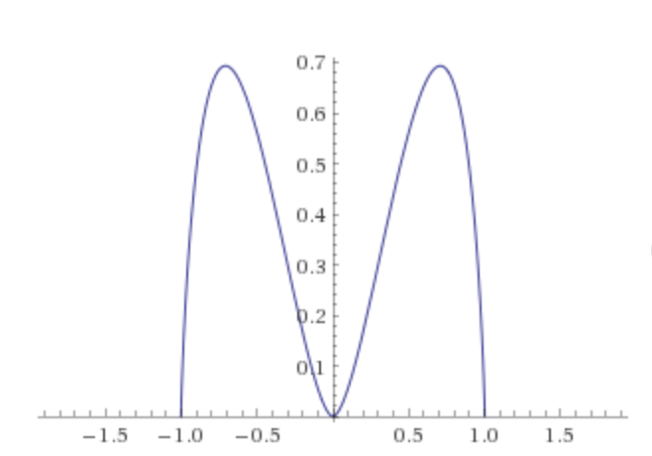

The above is the plot of the entropy function of x where entropy is on y axis and x parameter is on x axis.

* The entropy is minimum for x = -1.0, 0, 1.0
* We can mathematically find out the value of x for which entropy is maximum by differentiating the entropy function by x and seeing for what value of x is it zero.

i.e. dh/dx = 0

d (-[x2 log x2 + (1 – x2) log (1 – x2)])/dx

= -[2x2 log x + {log(1-x2) – x2 log(1- x2)}]

= -[2 x2 log x + (1- x2) log(1- x2)]

= -[2x log x2 – 2x log(1-x2)]

= 2x log((1/x2) – 1) = 0

Therefore, for x = 1/√2 and -1/√2 the entropy is maximum as the slope is +ve and –ve to the left and right for those values respectively.

Programming part:

Compile code:

* Import code zip file in eclipse and run ImageCompressor.java

Or

* Run the HW2.jar (java jar) by

java -jar dctdwt.jar /Users/diptejsaner/Downloads/test\ images/rgb\ images/Lenna.rgb 131072